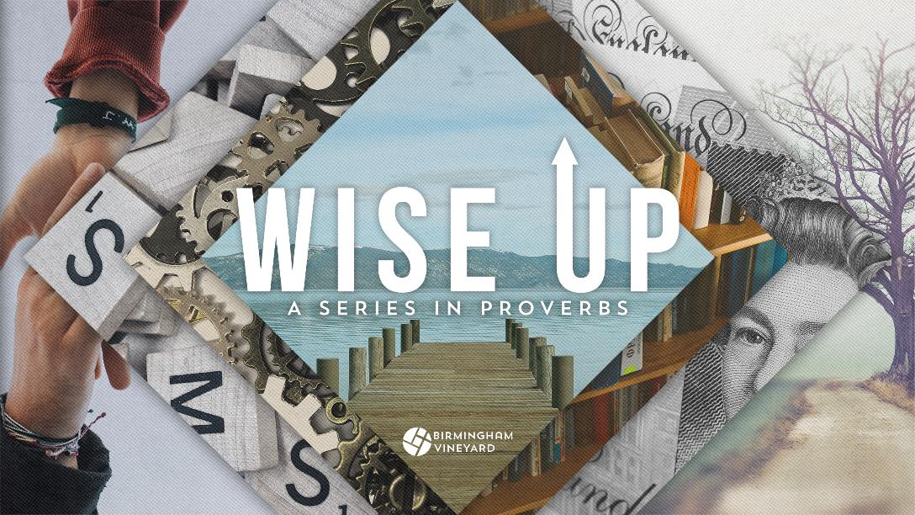
Wise Up! A Series in Proverbs
Wise Up

Date: Sunday 28th August Speaker: Jo Ramdas-Harsia (City Centre), Eleanor Masters (South)
Key Verses: Proverbs 9:10
Talk Summary:
God’s wisdom nourishes and refreshes our souls. But what is it about these wise sayings we've been exploring in Proverbs that are so captivating? Maybe it’s that they reveal more of God’s nature and character, because as we learnt right at the beginning of the series, wisdom is an attribute of God.
What is the fear of the Lord?
We need to get hold of an image of who God rightly is. We know if we have the right image of who God is because we will have a reverence and awe when we come before Him. And why is that important? Well because when we come before the Lord with reverence and awe, understanding something of who He really is, then all our interactions with Him start with who He is, not what I am or what I need.
What happens when you establish it in your heart?
The Bible also speaks of the benefits of having a fear of the Lord. Proverbs 22:4 shows that it can lead to ‘riches, honour and life’, and the idea of the fear of the Lord being life-giving is repeated in Proverbs – Proverbs 14:27, Proverbs 19:23; Proverbs 10:27 show this.
There is also security that can be found in fearing the Lord. Proverbs 14:26 and Proverbs 23:17-18 demonstrate this and show it’s something we should eagerly desire.
But the fear of the Lord is not exclusive to Proverbs. Psalms 112:1, and Psalms 128:1, speak of the blessing that comes from fearing the Lord as well as how it leads to obedience and holiness
What happens when you don’t have it?
If these are the consequences of having a healthy fear of the Lord in our lives, what does it look like when we don’t have the right understanding and image of who God is?
One consequence is that we start to look for influence, wisdom and comfort in all the wrong places. Online influencers, celebrities, people out of touch and out of reach.
When we look elsewhere for an image to inhabit, away from Jesus, this affects our perspective too. A lack of the fear of the Lord can lead to a mockery of Jesus and a terrible, petrifying fear of other things, even God Himself.
Jesus is the true image bearer, both of God and of us. We look to Him to understand who God is, but we also look to Him to see the image that we were meant to bear, who we were meant to be. Jesus is the security, the faithful and solid foundation on which we stand.
How can we follow Jesus’ example of living with a fear of the Lord?
Isaiah 11: 1-3
Jesus delighted in the fear of the Lord. He delighted in putting God first in all things, knowing God deeply as His loving Father, putting his Father’s will right at the centre of His life in all things. In doing this, he was able to see into the heart of every issue with God’s wisdom, understanding and perspective – judge situations and people rightly and make decisions perfectly in line with the will of God. If we choose to pursue and set the fear of the Lord into our own hearts, we will have access to the same clarity and power and of course the same wisdom and understanding.
Worship
Worship is not just singing, it is thanking God for who he is and what he has done and is lived out through a life of trusting obedience. Discussing this together is an act of worship.
(Small group worship resources can be found at bvc.so/sgworship)
- What are you thankful for this week?
- Where has God been at work in your life?
- When have you taken risks in faith and obedience this week?

If you have a time of singing you can skip the above questions but please do ask this question each week:
- What has God been speaking to you about this week? (Go around the group quickly don’t spend a long time on it)

Discussion Questions (choose some which are most relevant to your group)
- What can you think of in your own life that helps draw out the fear of the Lord in your own heart? How does that affect the way you live?
- When you look at the world around you, what consequences do you see of a lack of a fear of the Lord? How does that affect society?
- How has your own walk with Jesus and relationship with Him developed a keener sense of the fear of the Lord in your life story?
- How can the fear of the Lord in us benefit people around us - family, friends, work colleagues? How can it benefit the environments in which we live and work?
Witness - How would you share what you have learned with a non-church friend?
We want to be investing in authentic relationships with those who don’t know Jesus yet and inviting them to anything where they might meet other Christians and Jesus. Pick one of the below each week:
- How would you share what you have learned with a non-church friend?
    - What church events coming up would your friends appreciate an invitation to?
    - Upcoming Events (go to bvc.so/whats-on for details)
      - Encounter Night – 24th September at 7.30pm, City Centre Site

